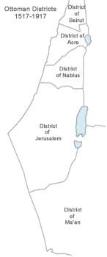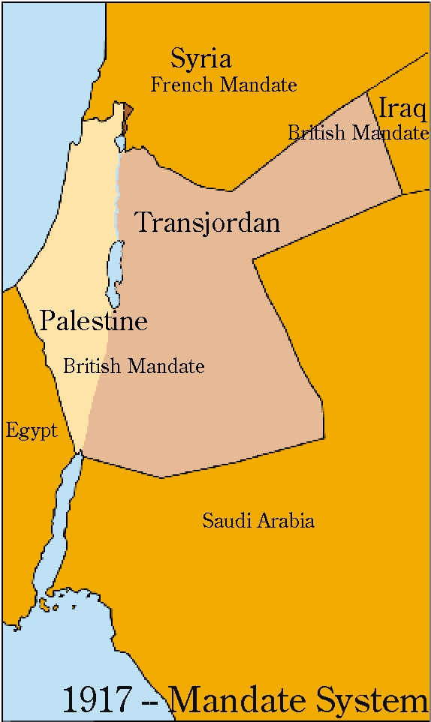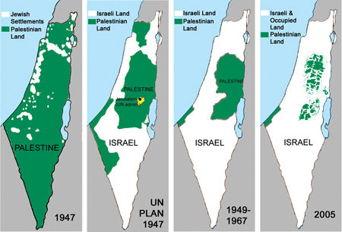

1. What trends do you notice in population and land shifts?
2. What could help explain these changes?

Sources for maps/statistics: Anna Baltzer Witness in Palestine: A Jewish-American Woman in the Occupied Territories (2007); ifamericansknew.org; Roberto Bacchi, The Population of Israel, (Jerusalem, Hebrew University, 1977), p. 5 found on Jewish Virtual Library, CIA Factbook. Maps on page 2: The CHOICES Program, Watson Institute for International Studies. Brown University.
Year | Palestinian Population | Jewish Population
1870 | 367,224 (98%) | 7,000 (2%)
1912 | 525,000 (93%) | 40,000 (6%)
1925 | 598,000 (83%) | 120,000 (17%)
1946 | 1,237,000 (67%) | 608,000 (33%)
1967 | 954,898 (WB/GS) + 390,000 inside Israel (36%) | 2,383,600 (64%)
2006 | 2,534,603 (WB/GS) + 1,722,600 inside Israel (44%) | 5,393,600 (56%)
2013 | 5,830,641 (48%) | 6,316,527 (52%)

